**ASSIGNMENT NO : 03**

|  |  |
| --- | --- |
| NAME: | WAJAHAT NAZIR |
| REG NO: | SP24-BSE-122-(B) |
| SUBMITTED TO: | SIR M.SHAHIS BHATTI |

**GUI**

First I created all required panels and text fields then added them to gird pane in specified places.

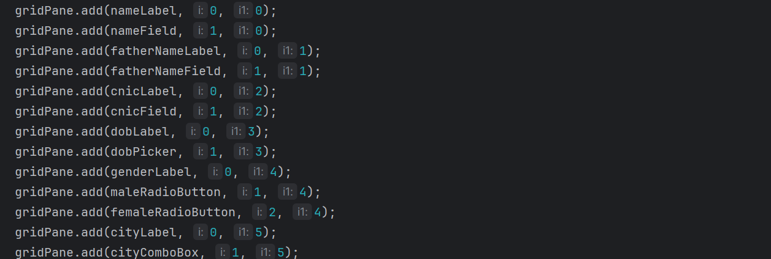

I added image on top banner .

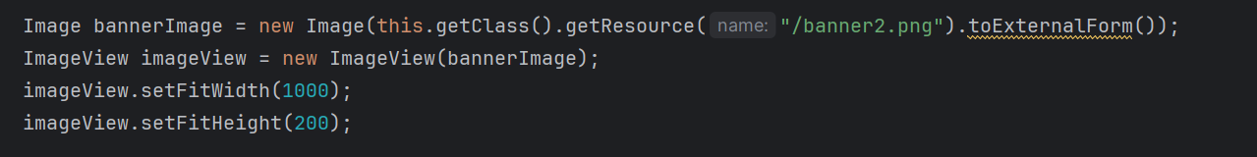

Then I applied some basic styling on each label and textbox for better user experience.

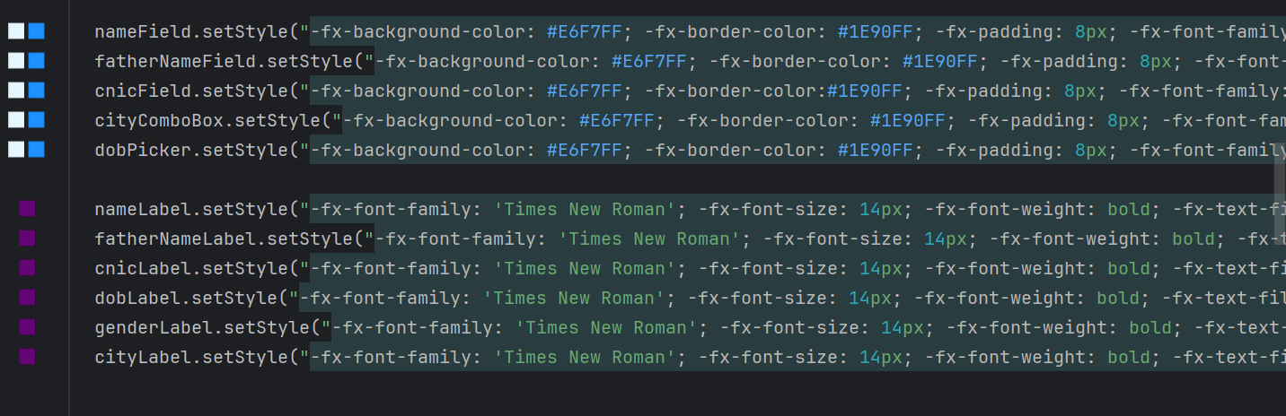

This is my code to add file chooser that let user choose file from the system.

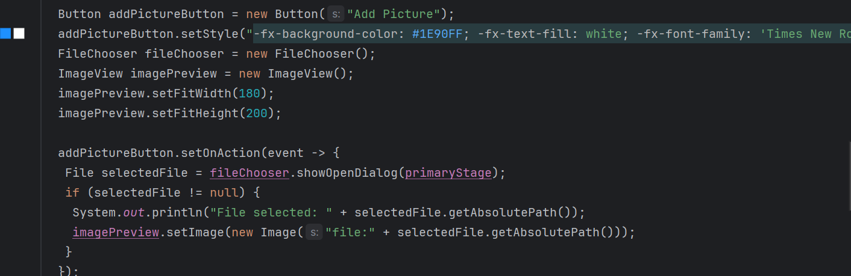

I added a bottom panel which consists of save and exit button.

Then I added every item to scene and launched the start method in main….so the output comes as:

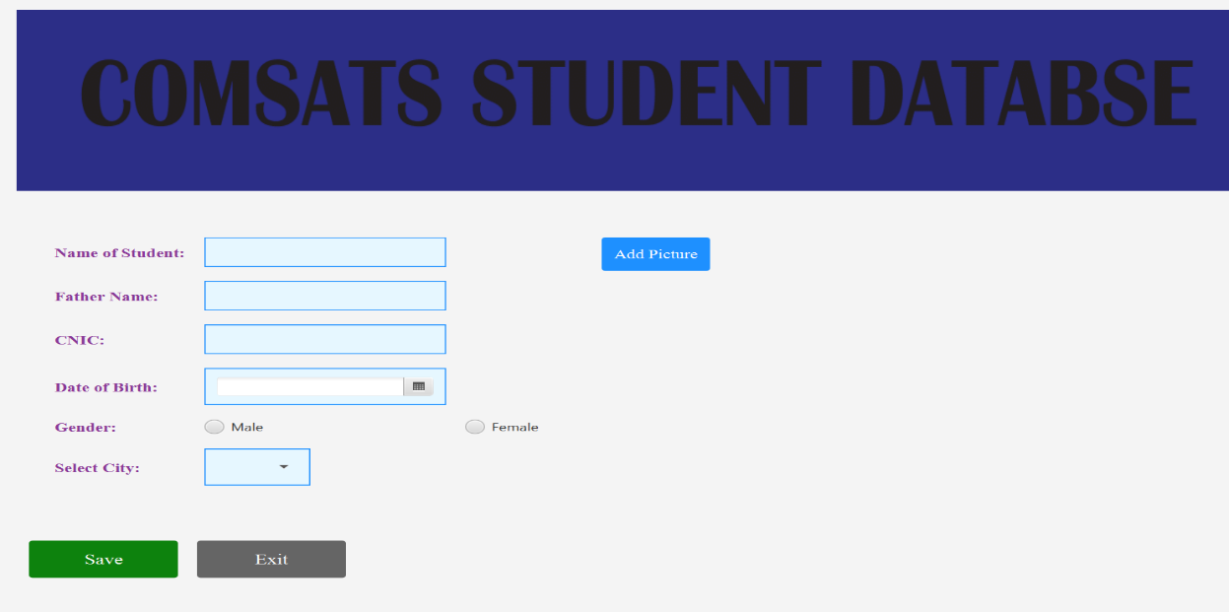

After filling the form the output looks like this:

